Exhaustive Movie Genre & Attributes Analysis Report
Exploratory Data Analysis & Baseline Genre Classification

1. Executive Summary
This report presents an exploratory data analysis (EDA) of a movie classification dataset of 50,000 feature films. It examines how films are distributed across genres, content ratings, directors, lead actors, studios, languages, and countries, and tests whether a baseline model can predict genre from the remaining attributes. The dataset appears to be synthetically generated: every category is almost evenly represented and genre is unrelated to the other attributes, so the results demonstrate an analytical workflow rather than real-world industry trends.
Key Performance Indicators (KPIs):
• Average Production Budget: $100,833,458.63
• Average Box Office Revenue: $502,128,893.22
• Duration Range: 80 to 180 minutes (Average: 130.0 mins)
• Average Audience Rating: 6.95 / 10
• Average Audience Votes: 249,445 per film

2. Genre & Content Demographics
The charts below show the number of films in each of the seven genres and five MPAA-style content ratings. Both are almost perfectly balanced: genre counts range from 7,090 to 7,203 and content-rating counts from 9,885 to 10,088. No genre or rating dominates the dataset.
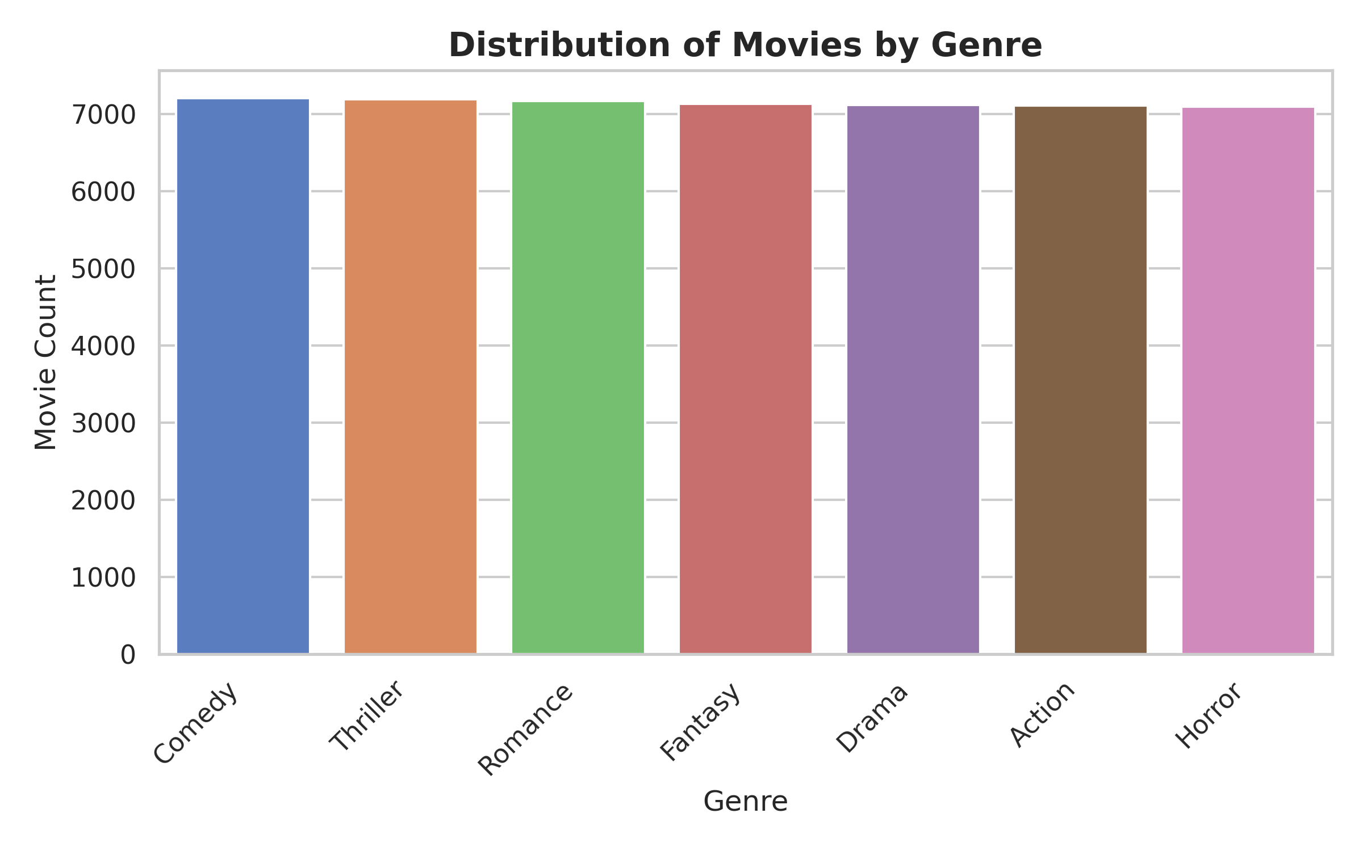
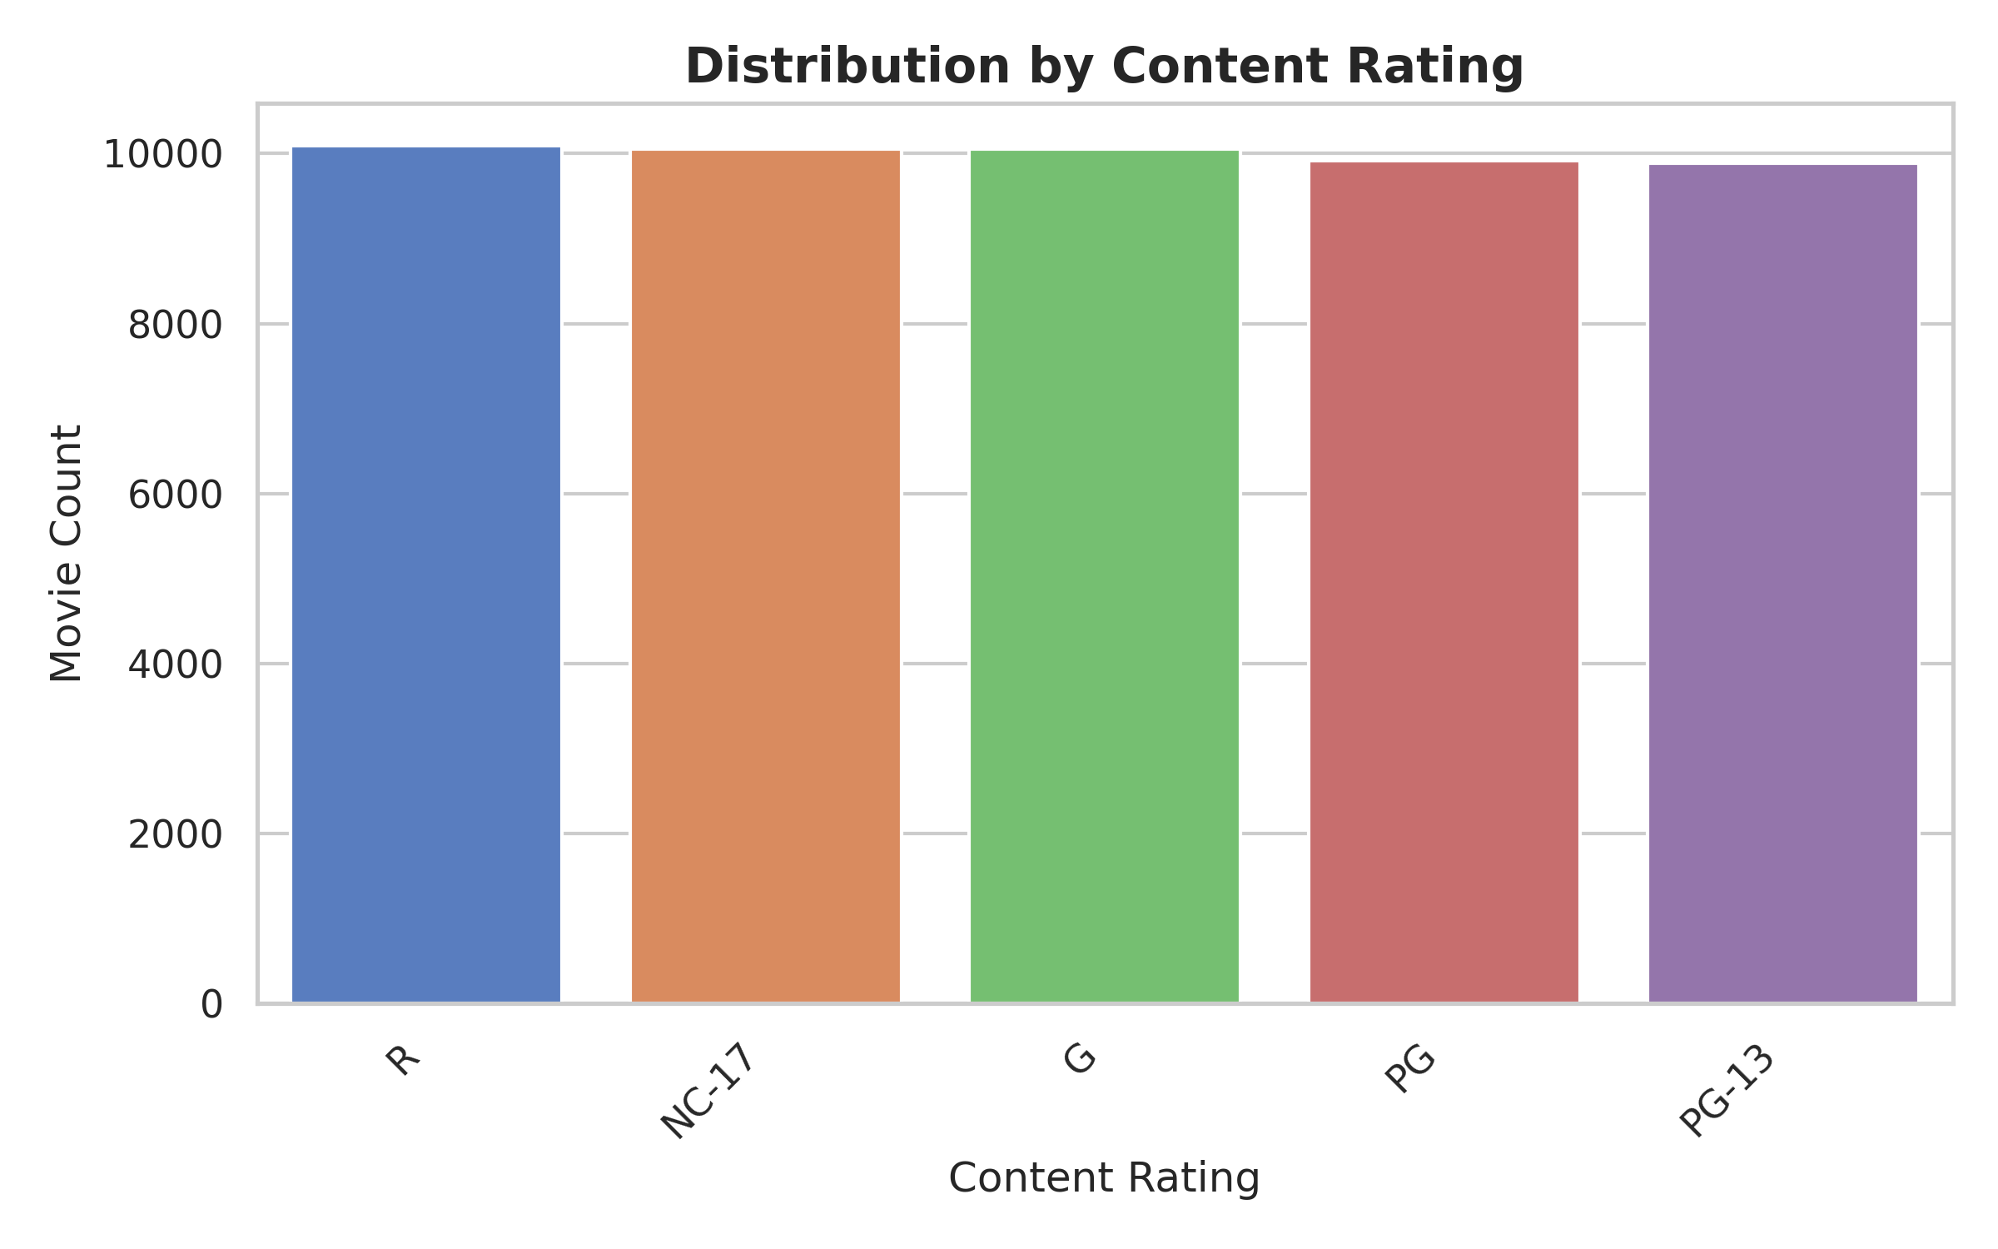

3. Key Personnel: Directors & Lead Actors
The dataset contains ten directors and ten lead actors, and each appears in roughly the same number of films (about 4,900 to 5,100 each). No individual stands out as more prolific than the others. Because the film counts are so uniform, they offer no basis for ranking talent, and any analysis of talent return on investment would need real, uneven data.
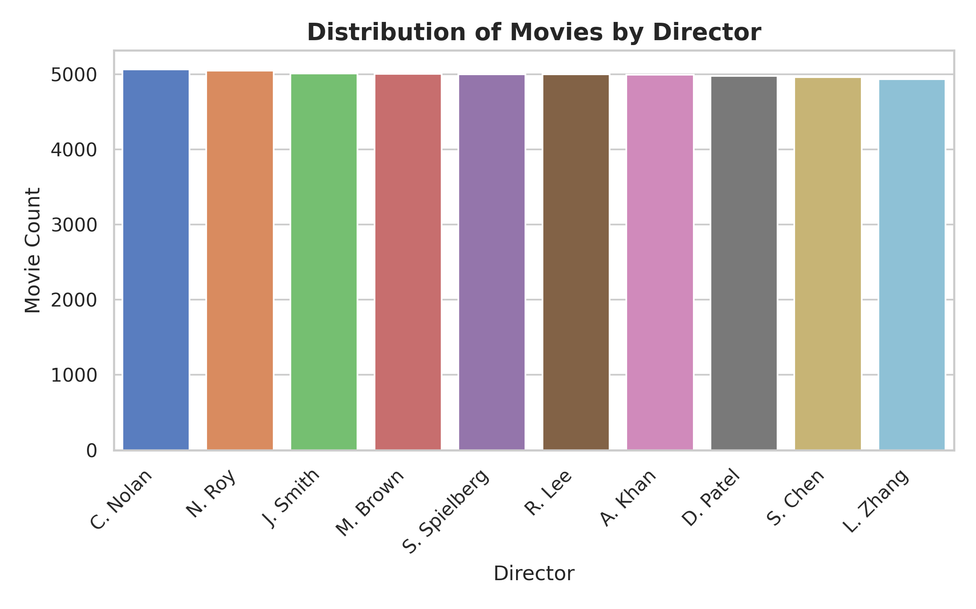
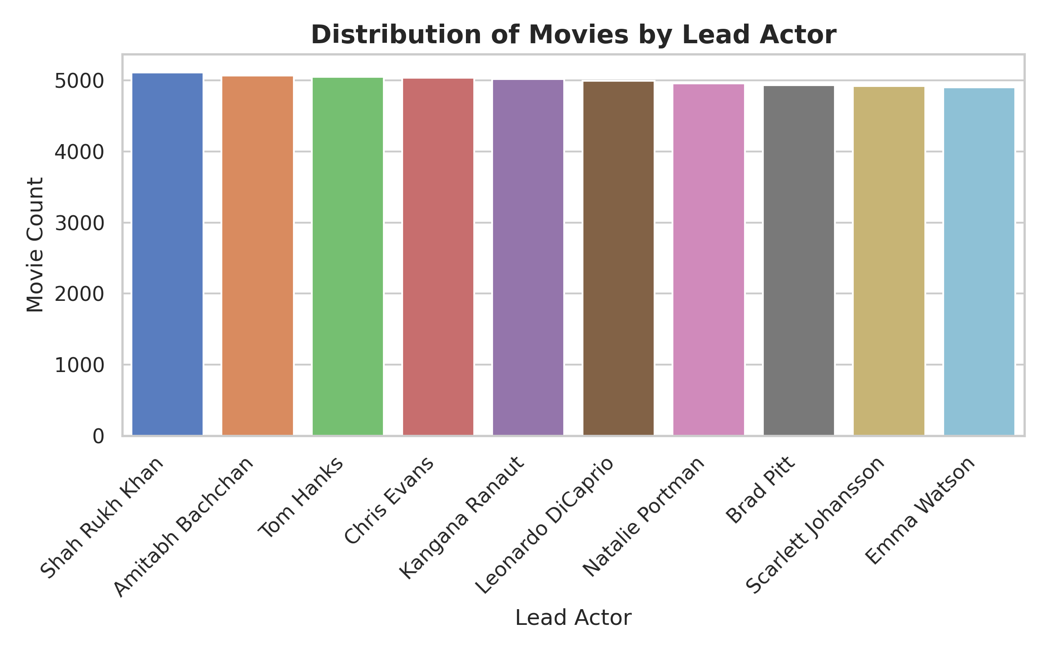

4. Market Origins & Studio Output
Films are spread evenly across seven languages, seven countries of origin, and ten production companies. Language and country counts each range from about 7,070 to 7,250 films, and every studio accounts for roughly 4,960 to 5,050 films. The data therefore shows no market or studio dominance.
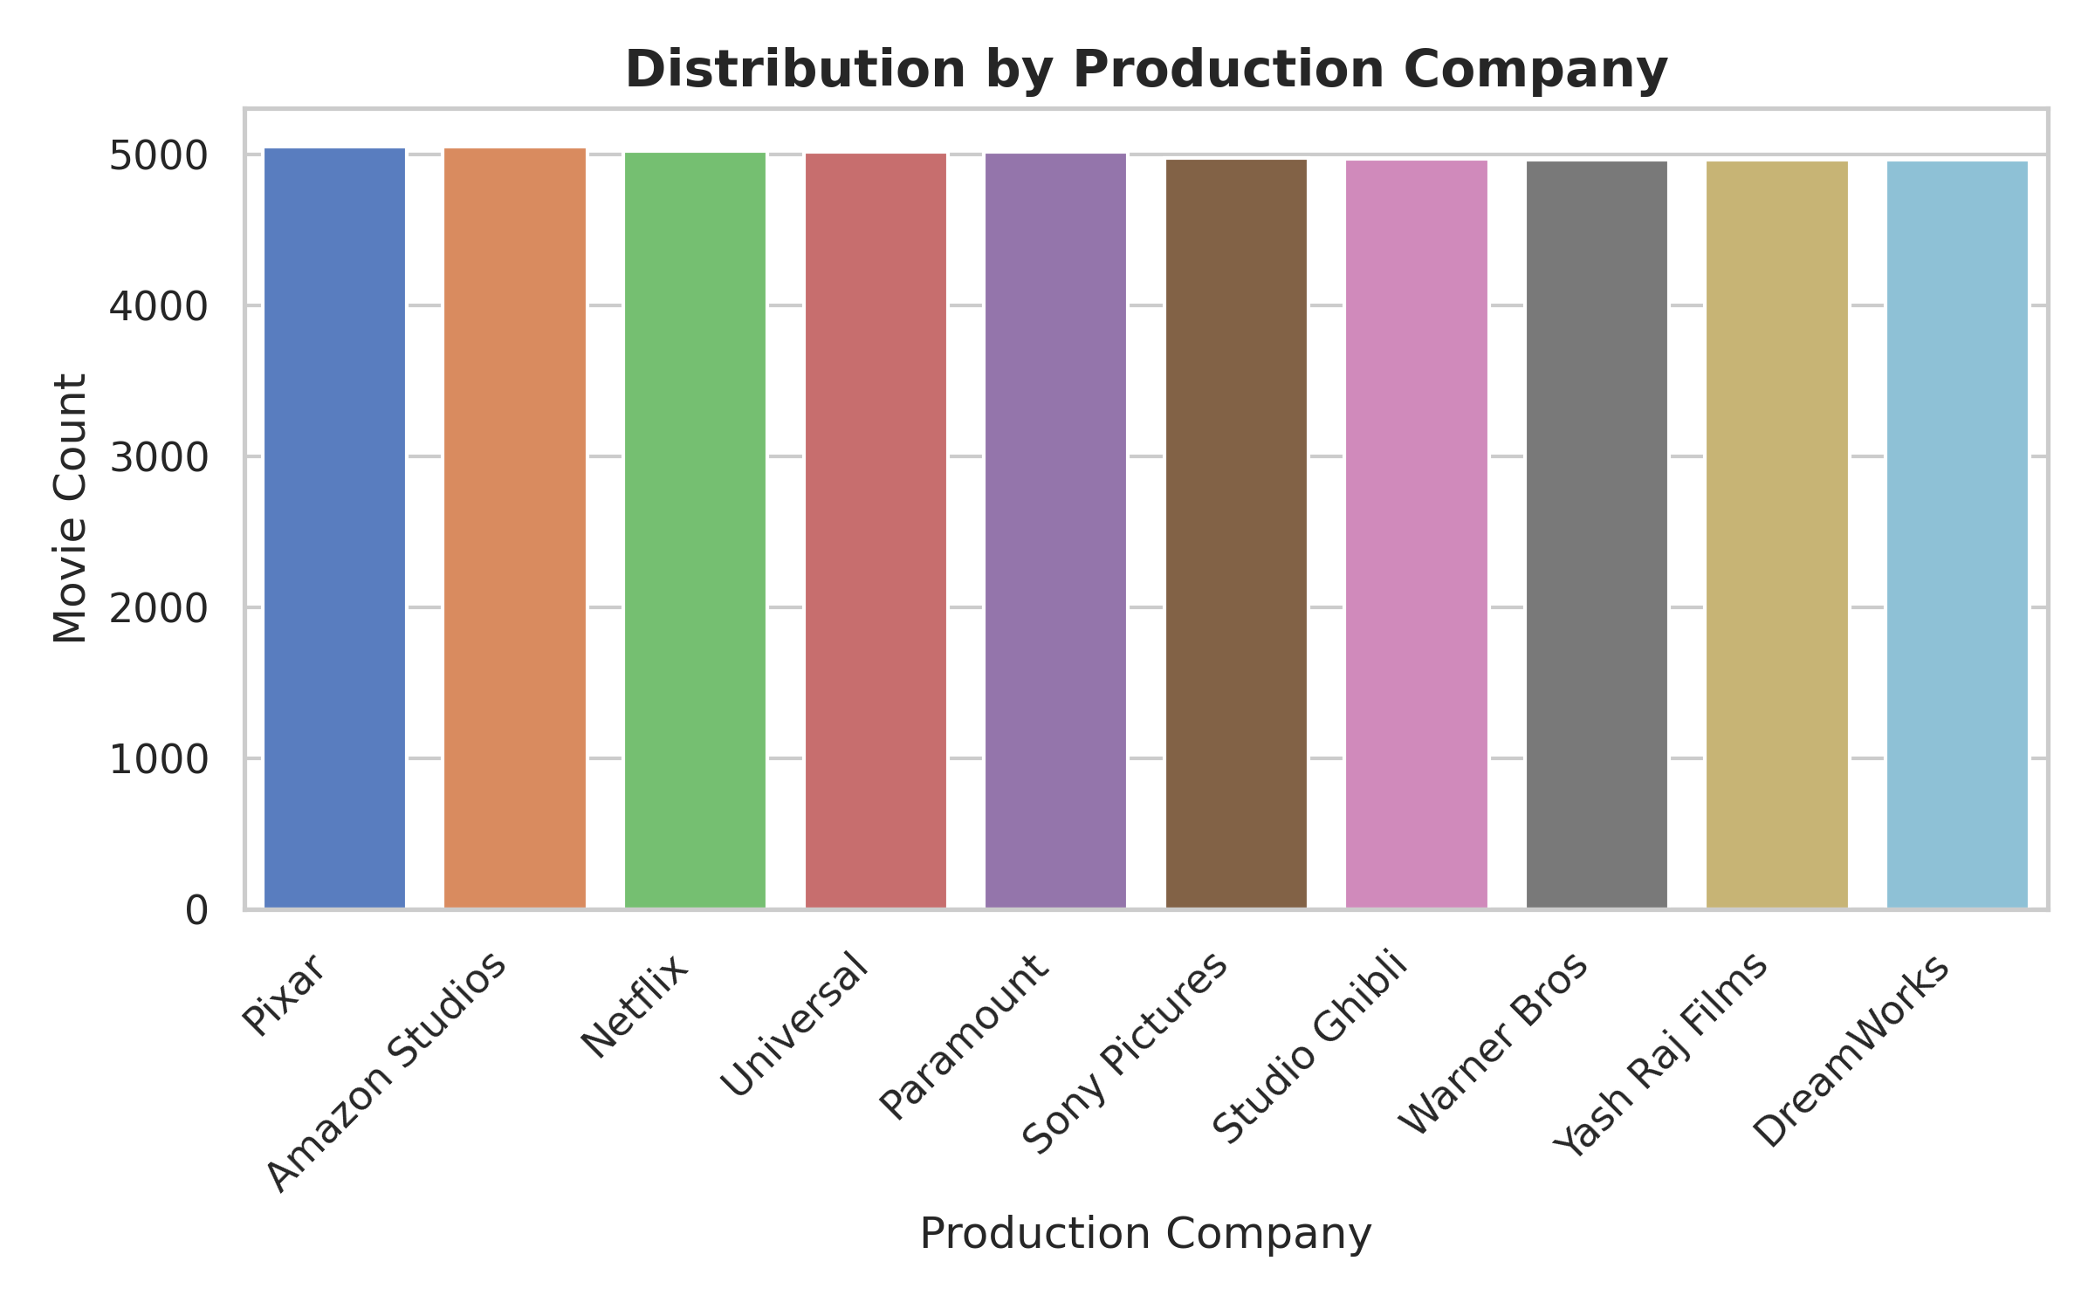
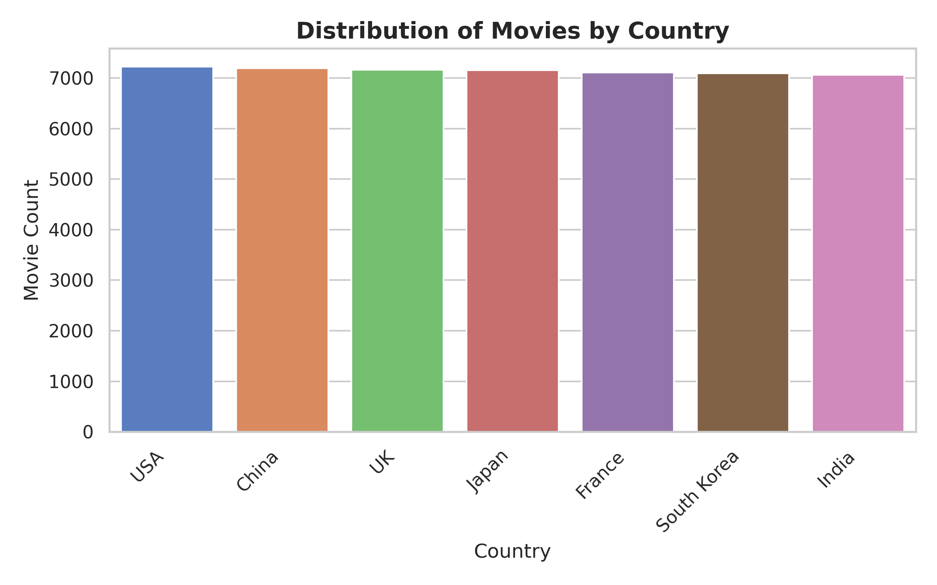
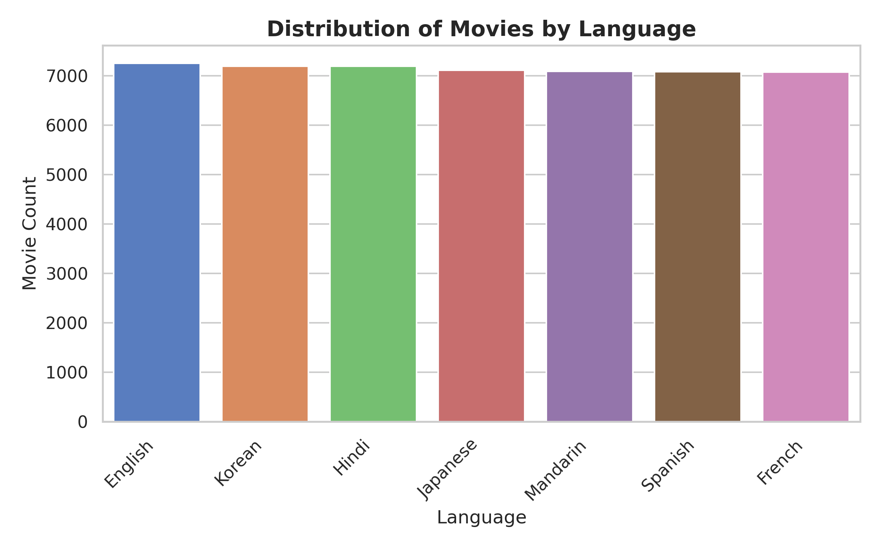

5. Conclusion & Next Steps
The analysis finds a uniformly balanced dataset with no concentration among genres, directors, actors, studios, languages, or countries. A Random Forest classifier trained to predict genre from the other attributes reached about 14% test accuracy, the same as the majority-class baseline and the 1-in-7 chance level, which indicates that none of the attributes carries information about genre. Together with the evenly spread counts, this suggests the data is synthetic. As a next step, the same workflow should be repeated on real film data, where text features such as plot summaries could be processed with TF-IDF vectorization and cosine similarity to build genre-classification and content-recommendation models, always evaluated against a baseline.

